FIELD REPORT
Introduction
Place: Railway seed secondary school
Location: Lira City Council
Date of visit: 27th August 2026
- General observations
- All assets listed on the delivery note were physically identified and verified on site.
- All verified assets had been engraved.
- Full access was provided to all areas and assets, allowing the verification exercise to be completed without physical access limitations.
Special notes
- The school did not have copies of the delivery notes for the items reportedly delivered under UgIFT, limiting the availability of supporting documentation for reconciliation with the physically verified assets.

TYPICAL 5 STANCE VIP PIT LATRINE BLOCK | 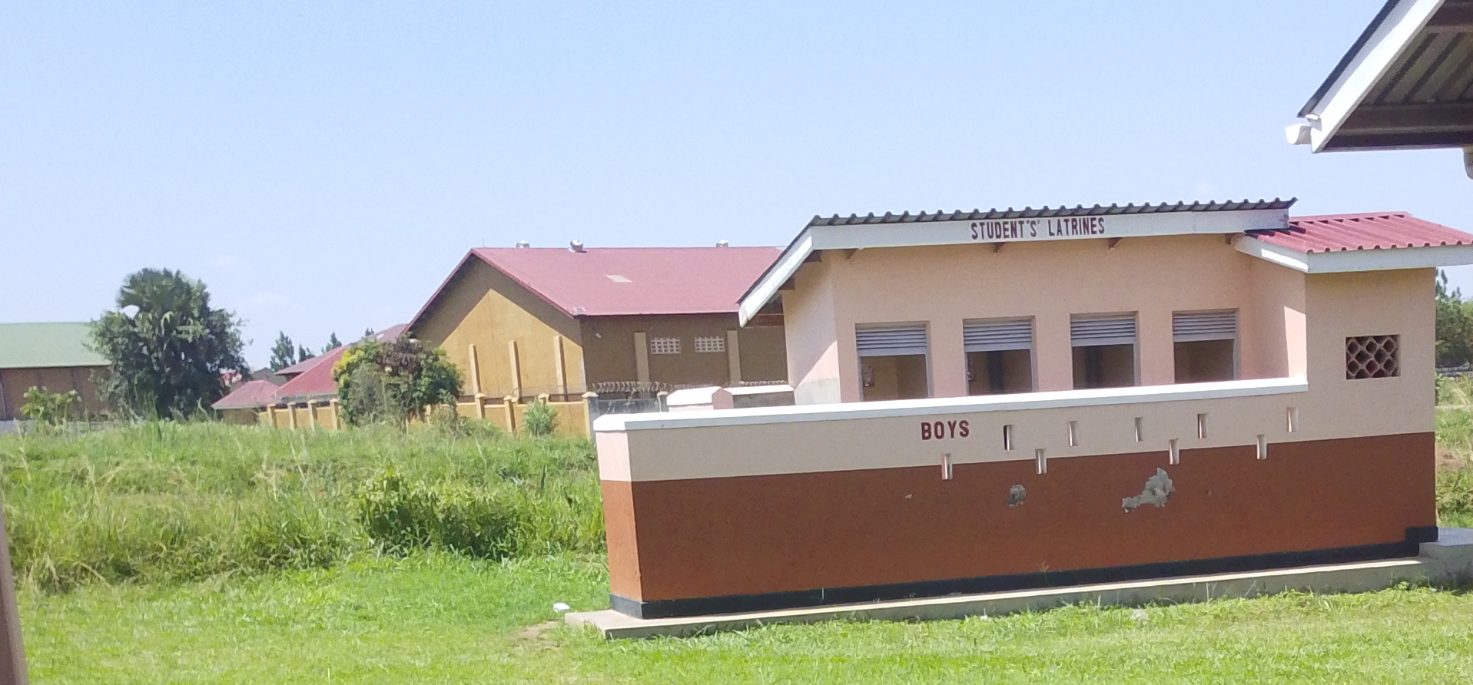
COMPUTER SET (MONITOR, UPS, POWER) | 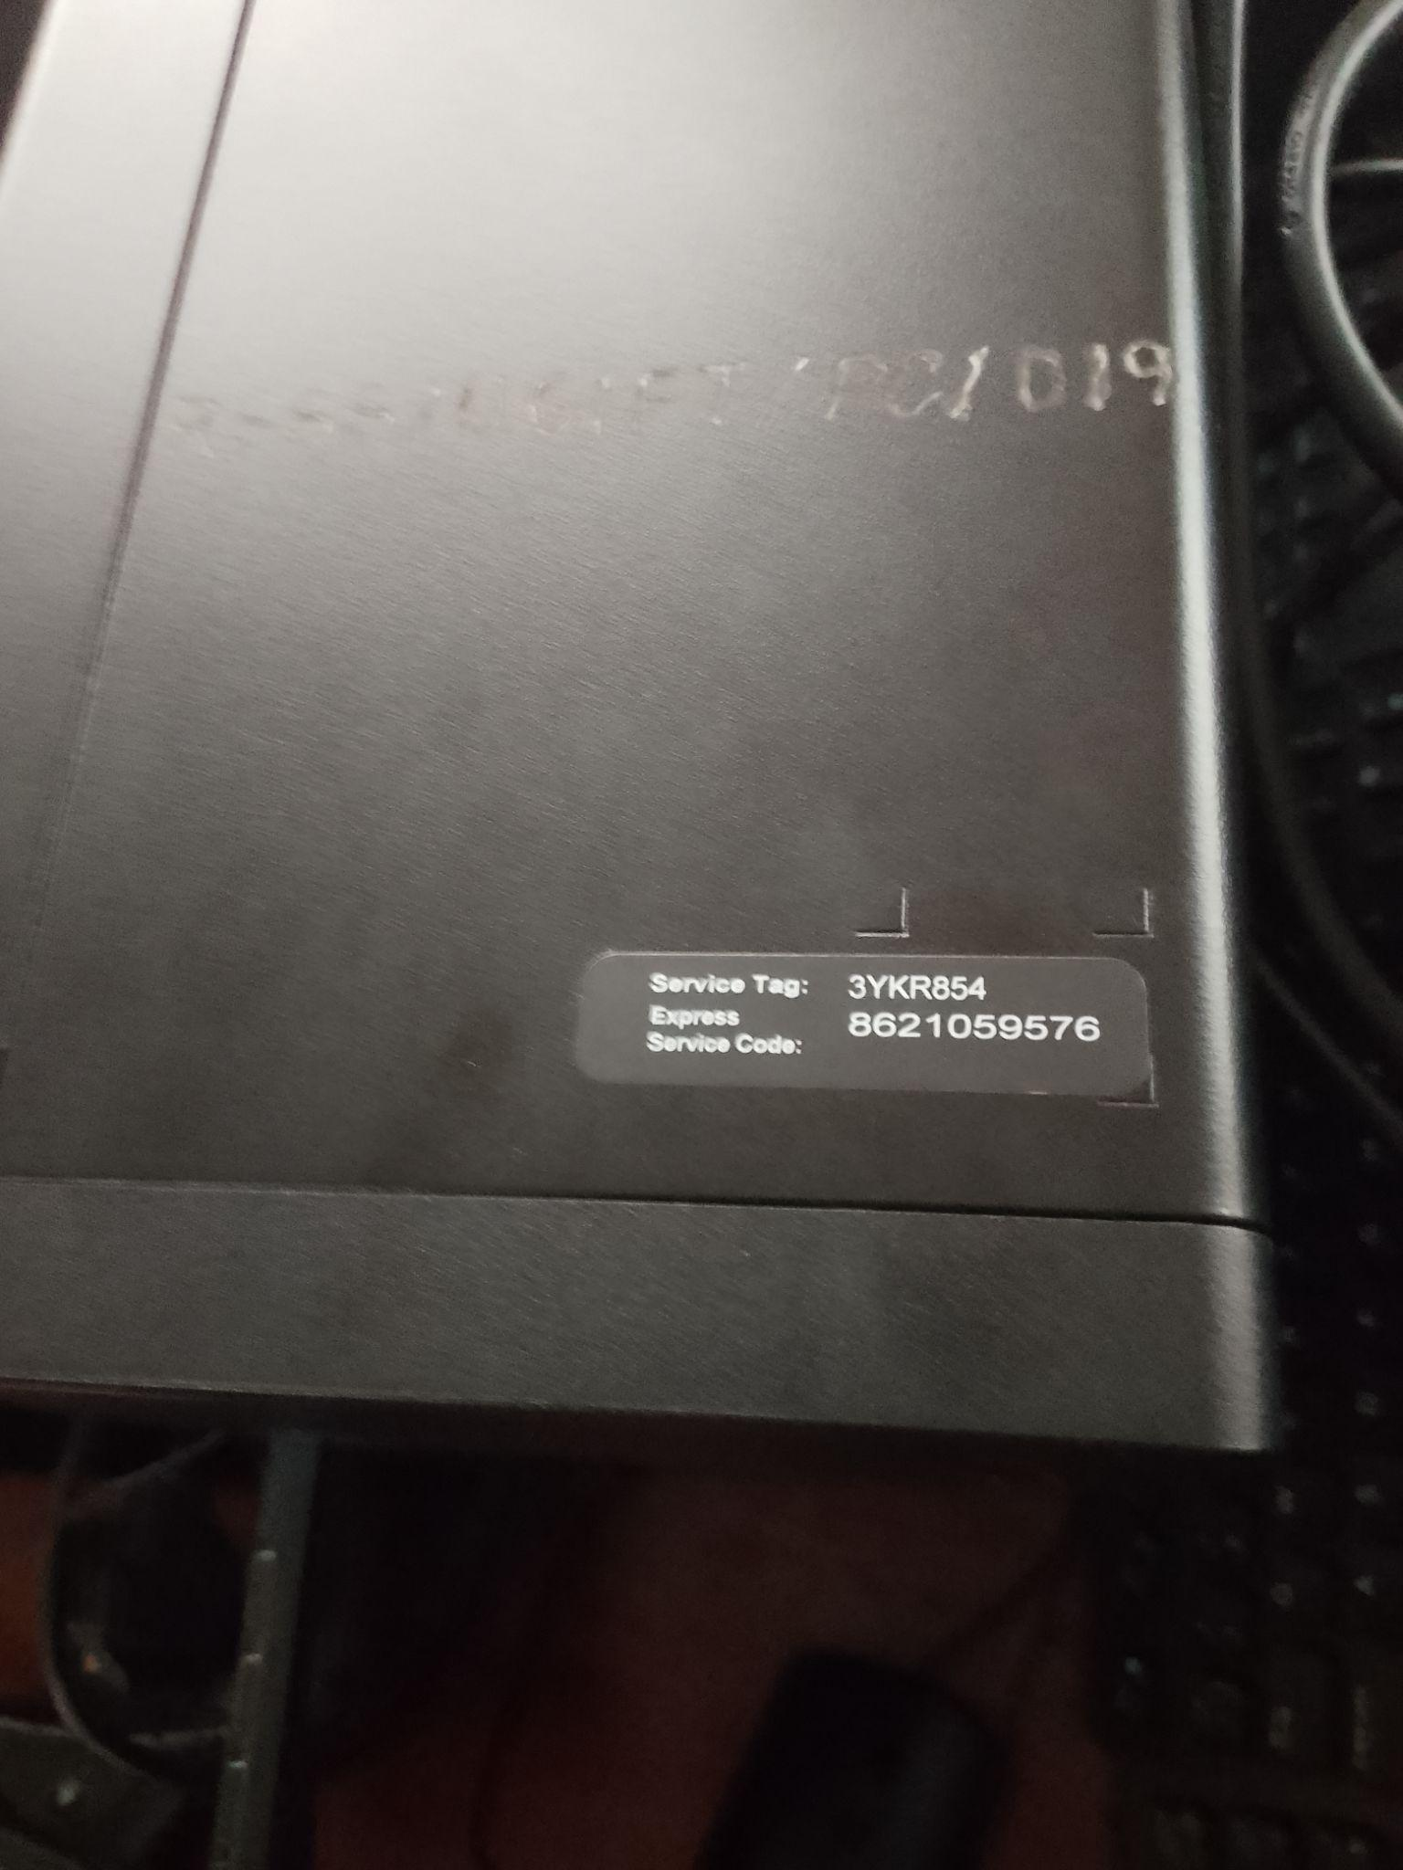
PRINTER | 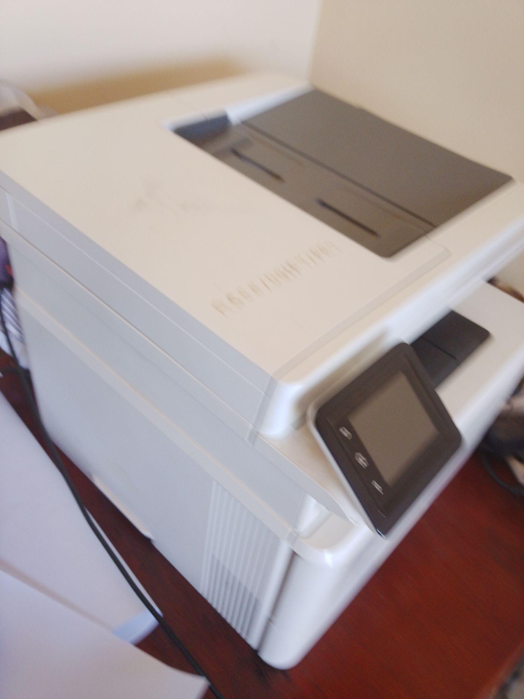
WALL LABORATORY TABLE WITH SHUTTERS AND SINKS AND WATER CONNECTION | 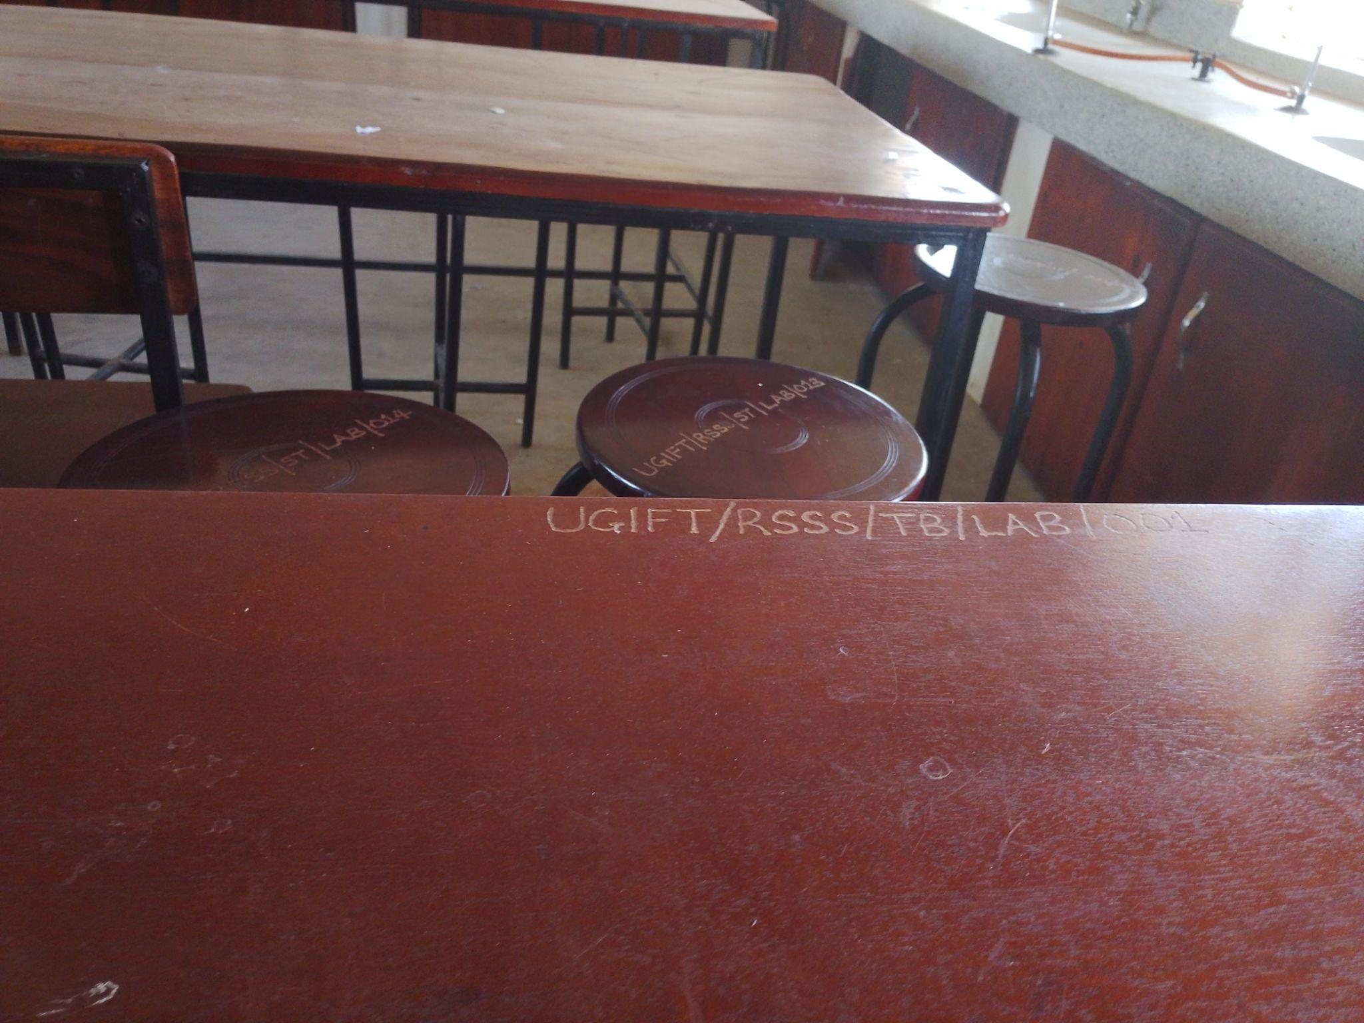
SAMPLE OF LABORATORY STOOLS | 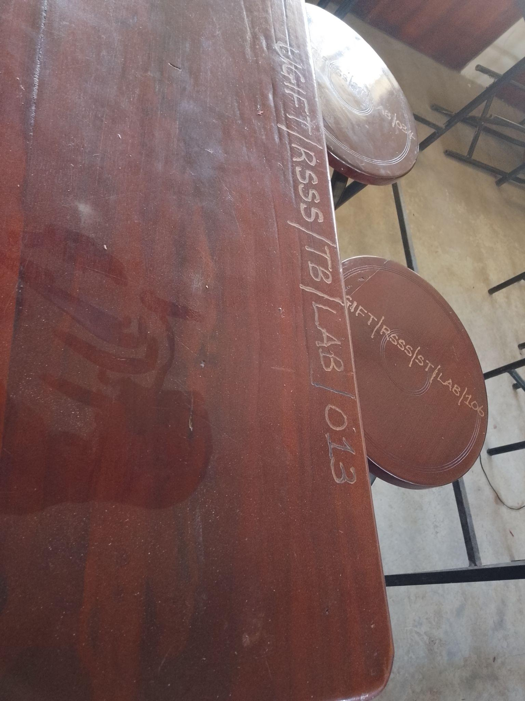
SAMPLE OF CHAIRS, ENGRAVED | 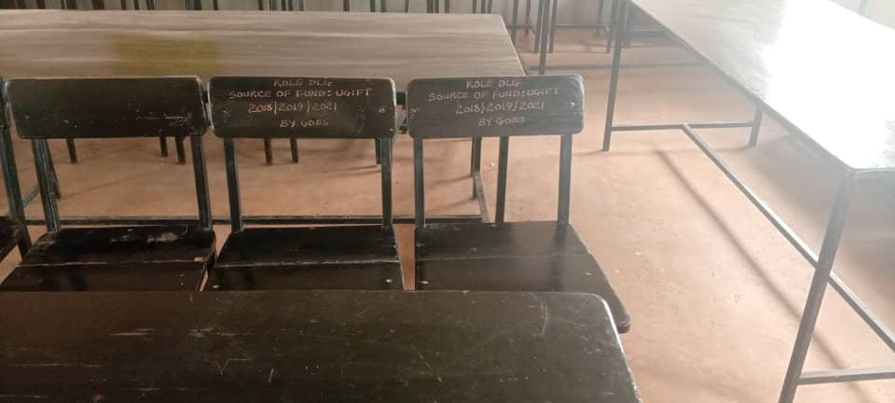
9KG-CO₂ FFIRE EXSTINGUISHERS | 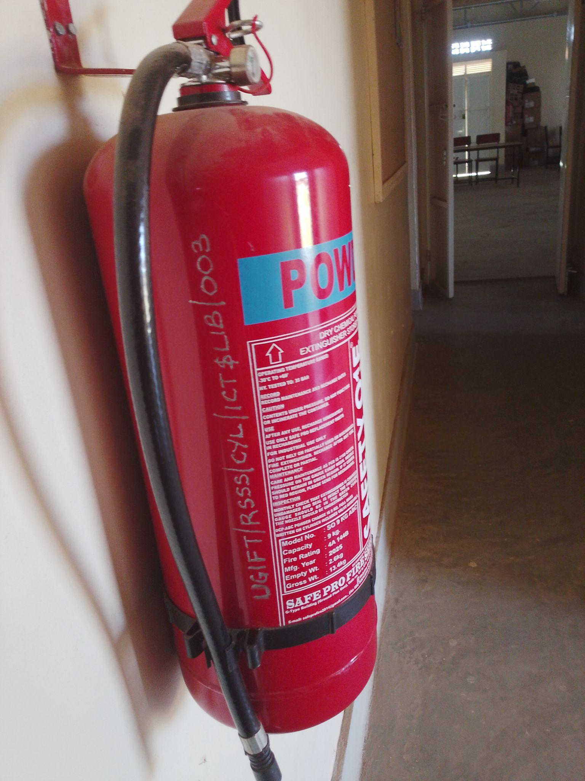
STAFF TOILETS | 